ĐỀ THI TRẮC NGHIỆM
Mã đề: 123
Kỳ thi: …
Môn: ….
Câu 1: Would you like to reserve the larger hall for the event?
A. Yes, that would be fine.
B. Yes, I’ve already completed it.
C. It’s bigger than the others.
Câu 2: Who is going to attend the Mr. McKenzie’s retirement party?
A. He has not arrived yet.
B. Let’s go right now.
C. Everyone except Jill.
Câu 3: What is the correct fomular?
A. $\vec{F}=m\vec{a}$ B. $A=πr^{2}$ C. $x=\frac{-b±\sqrt{b^{2}-4ac}}{2a}$ D. ${\text{a}}^{\text{2}}\text{+}{\text{b}}^{\text{2}}\text{=}{\text{c}}^{\text{2}}$
Câu 4: Would you like to reserve the larger hall for the event?
A. It’s bigger than the others.
B. Yes, that would be fine.
C. Yes, I’ve already completed it.
Câu 5: What is PI number?
A. 1. B. 4. C. 2. D. 3, 14.
Câu 6: Did you hear about John’s promotion?
A. No, I have not heard anything from him yet.
B. The sales promotion was successful.
C. Yes, he is being recognized for the great work he did on the project.
Câu 7: Who is in the picture?
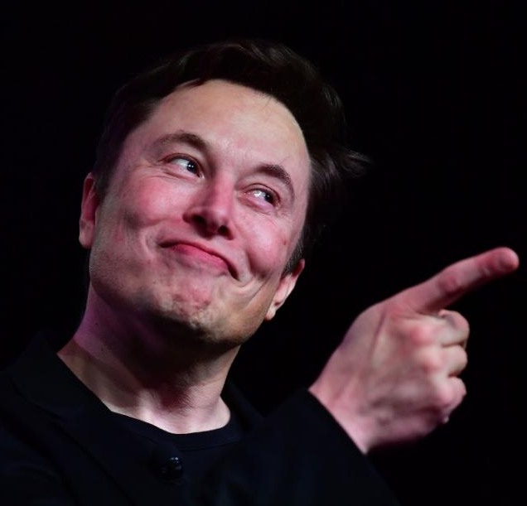
A. Larry Ellision.
B. Jeff Bezos.
C. Bill Gates.
D. Elon Musk.
Câu 8: Should I go over the material once again before showing it to the client?
A. That’d be a wise thing to do.
B. He is expected to show up soon.
C. It’s about our new product.
- HẾT -

